**First Slider:**

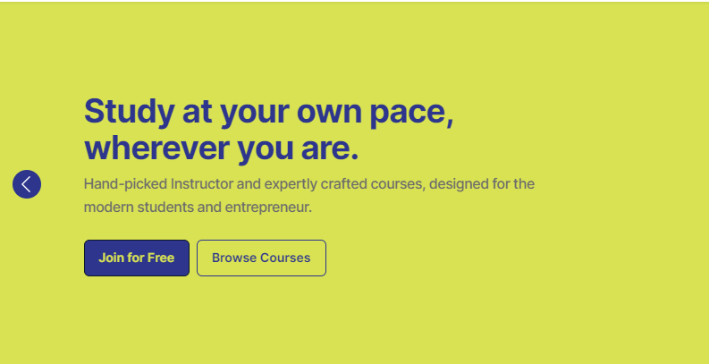

**Achieve Global Success with Flexible Learning:**Experience the flexibility and convenience of e-Ascencia’s online learning platform. Our courses allow you to study at your pace from anywhere at any time.

**Enroll Now** | **Browse Courses**

**Second Slider:**

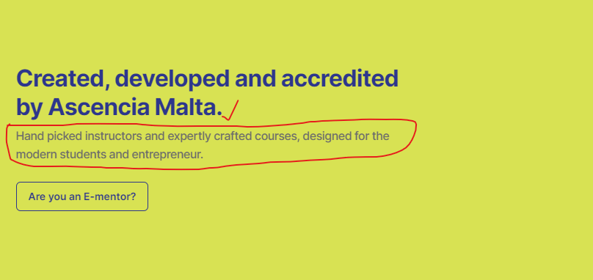

**Reach New Heights with Our Expert Mentors:**

Transform your potential and reach new heights with the personalized guidance of our experienced and dedicated mentors.  
  
**Are You E-Mentor?** | **Learn More**

**Third Slider:**



Enhance your education

Our programs boast global recognition through accreditation by the prestigious European Qualifications Framework.

**Register Now** | **Learn More**

**The Fourth Slider:**

**Explore Online Degrees & Diploma Courses:**

Discover expertly crafted courses developed by top instructors tailored for modern students to achieve global success.

**Register Now** | **Browse Courses**

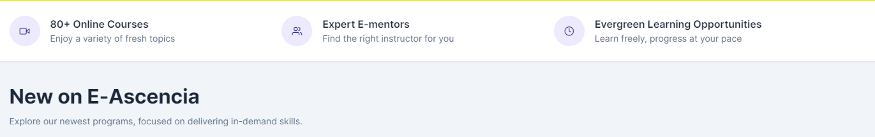

**Explore Online Courses:**   
diverse learning opportunities await.

**Our Expert E-Mentors:**  
guidance from trusted professionals.

**Our Learning Community:**connect, collaborate, and excel together.

**New Courses on E-Ascencia!**Explore Our Latest Programs Tailored to Meet Industry Demands.

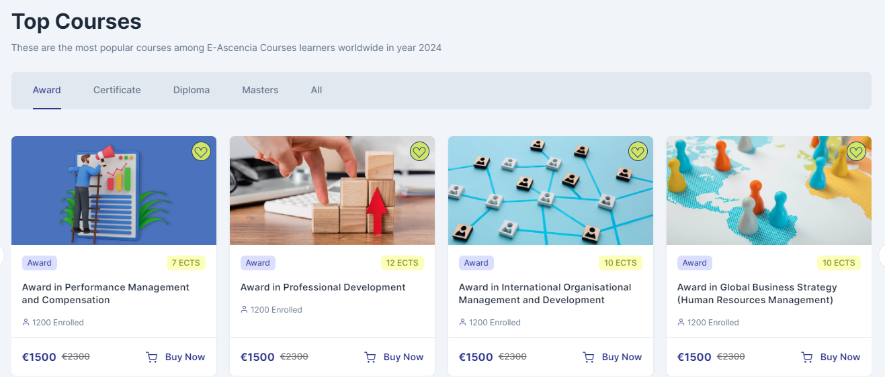

**Discover Top Courses:**Explore handpicked top-class courses crafted to enhance your learning experience and expertise effortlessly.

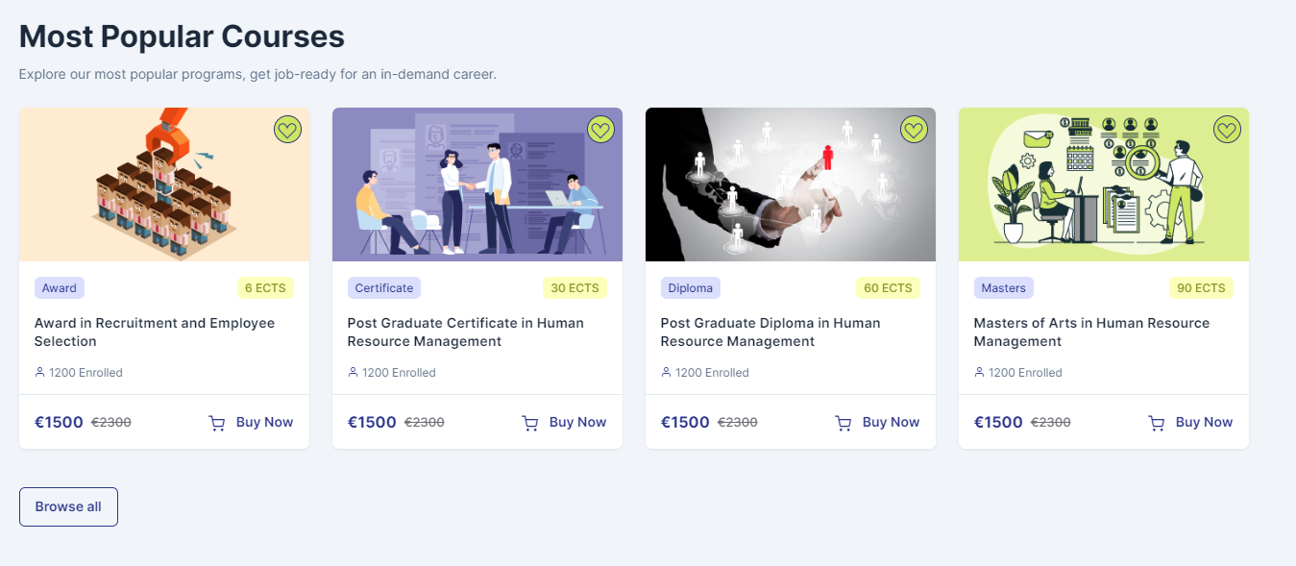

**Top-Rated Courses:**  
Explore Our Most Loved Courses - Tried, Tested, and Trusted by Learners Around the Globe for Quality and Relevance.

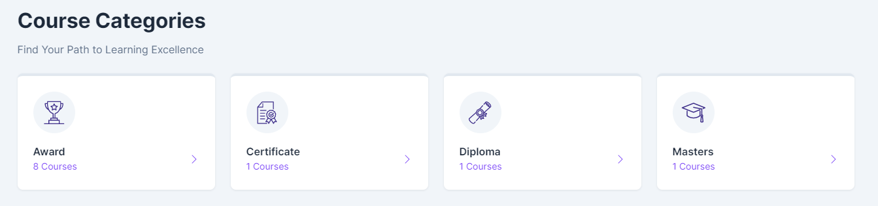

**Course Categories:**  
Browse Different Categories to Find Courses Aligned with Your Interests and Learning Objectives.

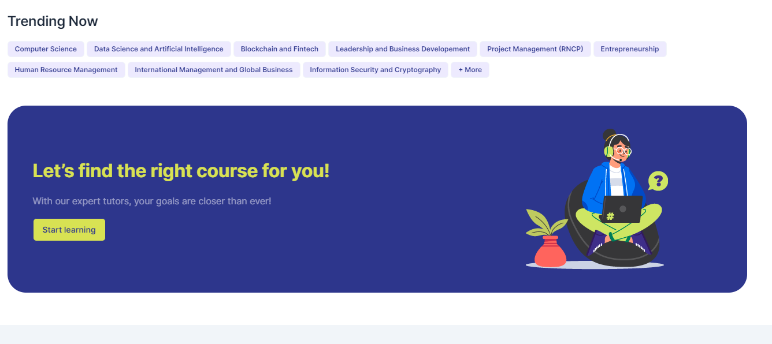

**Trending Courses:**

1. **Post Graduate Certificate in Human Resource Management**
2. **Award in Global Business Strategy**
3. **Masters of Arts in Human Resource Management**
4. **Award in Performance Management and Compensation**
5. **Award in Recruitment and Employee Selection**

**Begin Your Learning Journey Now!**Explore endless opportunities for growth and development with our expertly crafted courses. Take the first step towards enriching your knowledge and skills.

**Start Learning**

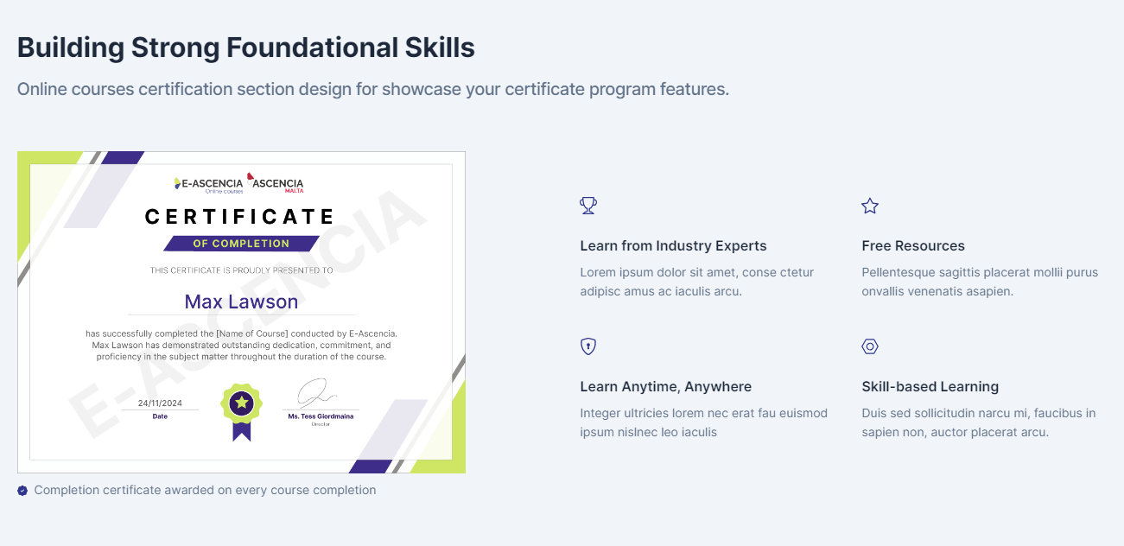

**Master Your Skills with Our Certified Courses!**Elevate your education with our MQF/EQF-certified courses. Aligned with international standards, they enhance your global career opportunities.

**Flexible Learning Schedule:**Study at your own pace from anywhere at any time.

**Globally Recognized Certification:**Earn certifications recognized by the European Qualifications Framework.

**High-Quality Course Content:**Discover top-notch education by top instructors.

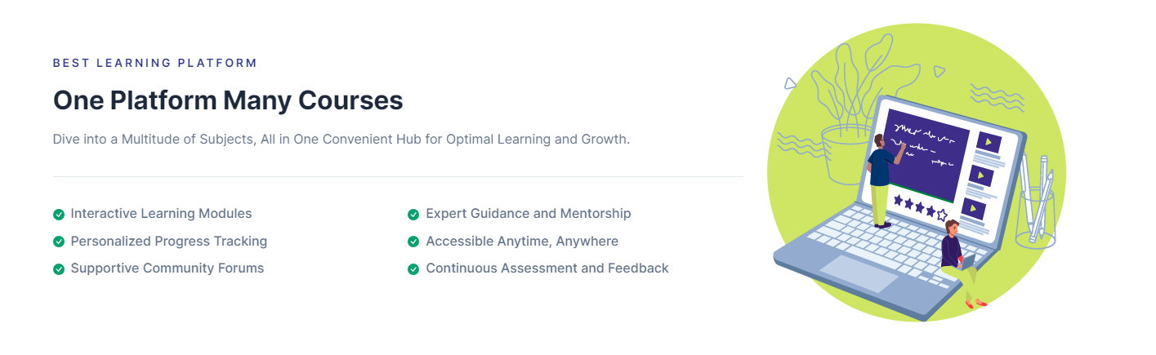**completion certificate for each course completed.**

**Premier Learning Platform!**

**Discover Globally Recognized Courses:**

We provide a comprehensive learning experience unlike any other, offering Masters and Bachelors programs in fields ranging from Human Resource Management to Computer Science, Leadership, and Business Development.

1. Interactive Learning Modules
2. Personalized Progress Tracking
3. Convenient Learning Access
4. Expert mentorship available
5. Continuous Assessment and Feedback



Explore various online courses known for their excellence and global recognition.

**Register Now!**

Join our exchange program. We are inviting teachers and PhD graduates to participate.

**Register Now!**